Inhalt
7. MATERIAL LANDSCAPING OF KYAKA II 1
7.1 Topographic Space-Making 4
7.1.1 Path-making and Path-Mapping 5
Path-Mapping 5
Path-making 7
Two different ways to synthesise 9
7.1.2 Conquering the Bush: Agricultural Space Making 12
7.1.3 Interim Conclusion: Turning Place to Space? 15
7.2 Assembling Space: Constructing a House 16
7.2.1 The Humanitarian and National Architects 18
7.2.2 Refugees as Constructors 20
7.2.3 Refugees as Painters 24
7.2.4 Collision of Planning and Practice: Between Temporary Housing and Permanent Living 28
7.3 Conclusion 29
References 31

7. MATERIAL LANDSCAPING OF KYAKA II

Generally, space rests on the formation of relations as a symbolic process which in itself has “no materiality in the sense of a physical substrate” (Löw 2016: 192) but is composed of elements displaying materiality. I hereby refrain from going into detail into what has been framed as a “material turn” in social science (e.g. Bennett and Joyce 2013, Hicks 2010), encompassing the focus on material culture (e.g. prominently represented by Appadurai 1988) and the agency of things (prominently represented by Latour 2005), but instead I remain with a “moderate materialism” (Günzel 2010) the chosen theoretical approach already encompasses with its explicit focus on both, the material and symbolic dimension of space (Löw 2016). Overall, this chapter seeks to analyse the positioning of human beings in relation to matter which can then provide answers in regard to the effects and production of space. It hereby links to growing interest on the question of materiality of and in refugee camps (among others Holzer 2014, Hartmann 2017, Abourahme 2015, Ramadan 2013, Mould 2018). The following chapter builds on that and focus on people’s practices in regard to matter to what I refer as material landscaping. In contrast to the previous chapter on social-landscaping, I concentrate on people’s practices involving things of matter and more particularly how they actively place them and thereby create and reproduce linkages stabilising the camp-arrangement. The analysis will include people’s practices in regard to substrates, such as soil, clay etc. but also activities with things and objects produced by humans, such as plastic sheeting, poles. Above all these practices revolve around the negotiations of the physical use of places and its effect which then produces question in regard to the space they are reproducing by that.

Spatial approaches have manifested that spatial arrangements, by actually restricting and guiding peoples movements as well as their direction of view, always mirror hierarchies and power relation and by that pre-structure peoples practices accordingly (for a more detailed description see chapter 3). This has found entrance in various empirical analysis. In regard to humanitarianism in general Smirl (2015) has provided an in-depth analysis of the spatial and material aspects of humanitarian intervention. She demonstrated how the spatial arrangements of humanitarian intervention constantly spatialize binaries and produce distances and thereby conceptualize the humanitarian imaginaries as “shared norms, institutions and legal frameworks that shape and constitute international discourse on humanitarian assistance” (Smirl 2015: 204). Focussing on one object in particular, McGinty (2017) demonstrated for example how a 4x4 as a symbol of international presence, becomes absorbed into the conflict dynamic, enabling certain practices and thereby proliferate a conflict situation as well as it is the mean of negotiation of status, power and distinction.

While the humanitarian spatial arrangement also shapes the experience and positioning of those who are – as the humanitarian personnel – ‘in the field’, it even more pre-structures the everyday experience of those who have limited say in the actual arrangement, which is mostly the target group- in this case the refugees.

For refugees, encampment per se is the materialization of people’s political isolation by placing them in rural and remote areas, referring to Douglas (2003 [1966]) as “matter out of place” (Malkki 1992: 34). Materiality plays a role not only by the physical positioning of the camp itself but also by relational arrangement of and within the camp. Although the spatial turn, rejected space as container of human practices, with specific attention to materiality scholars have brought to attention that some spatial arrangements are more container-like than others, especially for the people who are placed there (Schroer 2006: 177, in regard to refugee accommodations Hartmann 2020: 52-53). Since everyday routines are always linked with materiality the very same materialities can therefore restrict these practices notably, why as Hartmann (2020) describes in her book, people in refugee accommodations experience them as very strict and inflexible. This can affect a group at a whole or cut into populations, segregate them and/or affect them differently. With regard to gender for example, scholars have discussed the materiality of power relation in regard to gender and how this produces spaces of insecurity and violence particularly for women (Hartmann 2017).

Very dominant however is the spatial ‘othering’ of refugees. By identifying the spatial arrangement of refugee camps as “geography of fear“ (Hyndman 2000: 98) Hyndman commented on the spatial segregation of refugees, from the surrounding area as well as internally from humanitarian personnel. In a similar vein refugee camps are frequently compared to total institutions of Goffman whereby the spatial segregation as well as the time-and space routines of the inhabitants are controlled (Täubig 2009, Thomas 2000, Kreichauf 2015, Castles 2003). For example, Hartmann’s (2020) analysis of a communal accommodation in western Germany demonstrates how the material equipment and arrangement exercises control over mobility of the inhabitants as well as the placement of elements in the accommodation. In her analysis, leaning among others on Löw, she demonstrates how the one-sided control over placement contributes constantly to processes of othering as well as devaluations of the inhabitants, e.g by denying their ability and will to use common goods responsibly (Hartmann Seitenzahlen).

Yet, individuals are not only placed, but theoretically every individual can also rearrange themselves as well as included elements. Hartmann identified this and emphasizes the political character of rearranging practices of the inhabitants for example visible in “contested objects” (Hartmann 2020: 267 own translation) when for example a couch was constantly moved and re-moved. Her findings hereby link to an increased understanding of interaction with material objects as political expression and agency of refugees (Ramadan 2013), with scholars focusing for example on cement as a mediator of political naturalization (Abourahme 2015), or the (illicit) trade with goods as fundamental way of critique (Newhouse 2015), or the way socio-spatial props can contribute to moral boundaries (Holzer 2014).

Building on this, I shift the focus from the structural and technocratic design and implementation of the camp to the actual and everyday reproduction by its inhabitants by analysing how they, through the means of routines link social and materiel elements together and by their linking practices contribute to the concrete socio-material arrangement called refugee camp. This is especially appealing because the refugee protection approach in Uganda (outlined in detail in chapter 5) has a particular approach in regard of the actual assembling of the camp. In contrast to the above mentioned examples of communal accommodation, refugees in Kyaka II are allocated a vacant plot of land on which they then have to construct their own house. It is them who, by the means of assembling, weave the provided goods (e.g. jerrycan, plastic sheeting, poles, etc.) with a place (the allocated plot of land) together which can then be synthesised as house and ultimately to a camp. When, in the previous mentioned example of Hartmann the material design of the accommodation exercises power and control, this opens up questions in regard of the material effect in Kyaka II when people are creating and constructing their immediate living situation on their own. My following analysis therefore concentrates on very elementary practices of space-making of the inhabitants of Kyaka II. However, it does not – and simply cannot – represent an exhaustive discussion of all everyday practices used at site. Instead, it sheds light on insightful examples for these practices, and I chose to present these orientated towards anecdotes, demonstrating instances of linkages that reveal a great generality for other interactions with materiality in the camp. First, the everyday interaction and arrangement of people with the soil which I frame as topographic space-making and second how people are assembling elements together with the example of house construction.

7.1 Topographic Space-Making

The following section centres around the physical element of land and soil on which the camp is placed upon. I am hereby interested in peoples what Schroer (2019: 152), leaning on Serres (2013) frames “geopractices” referring to practices “with which the earth is permanently measured, processed, transformed, represented, imagined, interpreted, divided and appropriated” (Schroer 2019: 98 own translation). By exploring peoples geopractices which include among others “the building of fences, walls and other border fortifications, the different gardening activities, the digging of the soil, the sowing and planting seeding and planting, to building, designing, and inhabiting nests, caves and houses” (Schroer 2019: 152 own translation), I aim to explore how people in their everyday practices produce and reproduce the camp. The impact of refugees activities for the environment has been identified, yet mostly regarding environment effects (Rashid et al. 2021), this section however, is less interested in the spatiotemporal effects but instead at the socio-spatial reproduction of the camp. In particular I concentrate on activities rearranging the soil or the fauna first by walking, which solidifies soil into paths etc. (Section 7.1.1) and second by agricultural practices (Section 7.1.2).

7.1.1 Path-making and Path-Mapping

The refugee act 2006 designates “places or areas on public land to be transit centres or refugee settlements” (Uganda 2006). By that a camp starts to materializes on a politically defined territory which is practically measured and exercised by the respective representative of OPM in the camp. Whereas a place – in this case a given territory - is the precondition of a space or as Löw frames it “the goal and result of placements” it is interdependent with space as the “sense of place develops with the placement” (Löw 2016: xvii). The actual reproduction gives way for the synthesis of different spaces at the same place, when the synthesis of the planning level meets appropriations in the actual spatial practices. In the following these existing inconsistencies and unevenness between planning and doing will be discussed by exploring path mapping as well as path-making.

Path-Mapping

It has been established now that power is mediated by the decision over the placement, which in regard to refugee camps lies with national or humanitarian actors. Generally, the physical outline of Kyaka II, ergo the decision on where streets are constructed or buildings to be placed lies under OPM authority. The actual construction and funding of infrastructure is exercised by implementation partners, often involving various stakeholders, and planning authorities. Scholars have criticised this top-down planning of the camp as a spatial form of disciplining and controlling its inhabitants (Hyndman 2000) [seitenzahl] or at least as inaccurate to meet peoples needs because of the lack of the involvement of the people affected by the very same infrastructure (Elorduy 2020, Smirl 2015). [seitenzahlen] For example, Elorduy (2020) described this tendency in regard to the planning of schools:
“Off-site predefined designs are the norm, usually developed by foreign consultants or local contractors with little to no involvement by learning-environment-design experts. The location of these centres is usually chosen by camp managers based on numerical data – which is often outdated and partial, as managers lack detailed and up-to-date maps of the camps and do not consult refugee inhabitants about their knowledge of the camp” (Elorduy 2020: 368).
As a result, the externally chosen location as well as the actual design of the buildings can negatively affect children’s attendance to schools due to inadequate consideration of “distances and pathways of access, the aesthetics and the materiality of the building, the safeness and security of the compound, access to drinking water, child-friendly toilets or the provision of nutritious food and play materials” (Elorduy 2020: 368).

As the example of the school demonstrates the planning of the camp, is often aggravated by inadequate accessibility or actuality of the information and the appropriate recording on respective maps. Generally the obtainment of accurate information in the camps is challenging as Inhetveen has discussed in regard of the shortcomings of a camp-bureaucracy in Sambia, caused among others by the limited interaction between bureaucracy and inhabitants (Inhetveen 2010: 372 - 374). Inadequate mapping can result in serious shortcomings for the general provision of infrastructure. For example, when malfunctioning or old boreholes are still mapped as a source for drinking water, it prevents the planning of a new water source. On the other hand, which elements are included in the maps, also display an inadequate consultation of the people actually living there, as a project, promoting community mapping in calais explains:
“The existing maps from NGOs and public facilities are customized for specific purposes which don’t necessarily align with the perception and needs of the camp residents. These needs include street names, signposting and rapid updates of free wifi hotspots and mobile charging stations“.
This can also make the service delivery inefficient which is increasingly brought to attention also by UNHCR and led to several projects aiming for an increase of mapping using technical devices and programs such as GIS (Quinn et al. 2018, Beaudou et al. 2003). Apart from using technical devices and tools, several projects have identified people’s knowledge and push to include them into mapping processes, by participatory mapping projects (Tomaszewski et al. 2017), e.g in refugee settlements in northern Uganda (Poisson 2013). By that they acknowledge an expertise which can only be gained through everyday exposure to their immediate environment which provides primary insights into topographic features.

What the participatory community mapping demonstrates is that by including people in the process on the one hand the accuracy and immediateness of available topographic information increases, caused by spatial knowledge of people which is pre-structured by the exposure to the environment. On the other hand, it helps to understand that this knowledge is also based on the space-shaping practices of people in their everyday practices, as through their regular mobilities they are creating infrastructures, such as solar panels, childcare centers, alternative pathways etc. they are then mapping. In more theoretical framing this means that people are not just passively surrendering to the spatial structures but instead engage in space-appropriation. This has been described for example by Elorduy [seitenzahl], when the children are creating shortcuts or hidden pathways in order to increase their safety while walking to schools, but it is also demonstrated by mapping the boda-boda movement in the camp of a project of hotosm [quelle] which highlights the alternative routes taken by boda-boda than by the humanitarian jeeps.

Path-making

Taking the idea of an alternative of roadmap of Kyaka II as example for geopractices of refugees one can see that also in Kyaka II with a limited number of official streets and houses often located far from it, a net of alternative pathways developed. Whereas every cluster is linked by a big gravel road, providing the access especially for the humanitarian jeeps and trucks, people are often allocated a plot of land without any infrastructure connecting it to the streets of the camp. Making a path, linking their house to the nearest street is therefore one of the first spatial practices refugees engage in. This expands to routes to their gardens, neighbours etc. and shortcuts connecting two different clusters. By walking the same route regularly, they re-arrange the land by removing the grass and create visible paths, also more likely used by others. This means that pedestrians are spatializing by the very material path-making of shortcuts. By establishing an alternative path, the physical accessibilities and therefore the street mapping of the arrangement changes.

These footpaths are not officially mapped, much less known and a humanitarian staff confined me that he would be lost without a car in the camp. The divergence between maps, marking official service roads and not officially recorded paths is not particular for refugee contexts. De certeau (Certeau 1988) indeed based parts of his spatial theory on the divergence between the pedestrians and city planners. He discusses the relation between the abstract view of scientist, urban planners etc and the perspective of the walking “ordinary man” and sees neither as able to fully grasp the picture of a city. While the abstract planers can create the silhouette of a city it is the practices of the “ordinary men” which are constituting for space as “[t]heir intertwined paths give their shape to spaces. They weave places together. In that respect, pedestrian movements form one of these “real systems whose existence in fact makes up the city.” […]" They are not localized; it is rather they that spatialize” (Certeau 1988: 97). Although the planners can identify the streets and houses it is the shortcuts which remain invisible for the viewer above.

In the camp these newly created paths are sometimes out of pure necessity, since there is no other path available. The new formation however is pre-structured by the access roads and location of offices and schools and so on but also the topographic dimension of the camp, including knowledge over rivers, animals, available resources etc. In this “ensemble of possibilities […] and interdictions”, De Certeau still detects a choice when the user makes a selection and by that “picks out certain fragments of the statement in order to actualize them in secret” (Certeau 1988: 98). It is this moment of selection, which demonstrates their expertise over the immediate surrounding.
For refugees, apart from creating their own infrastructure, and appropriating space according their own needs, walking as space-making practices also entails and contributes to processes of synthesis of and in the camp. I have tried to capture this alternative street map by asking one participant to draw me a map of Kyaka II. While he was not able to draw all the shortcuts and alternative paths an alternative sense of distance in contrast to the official estimations based on cars and gravel roads, as well as different names than the official cluster names could be captured by that.
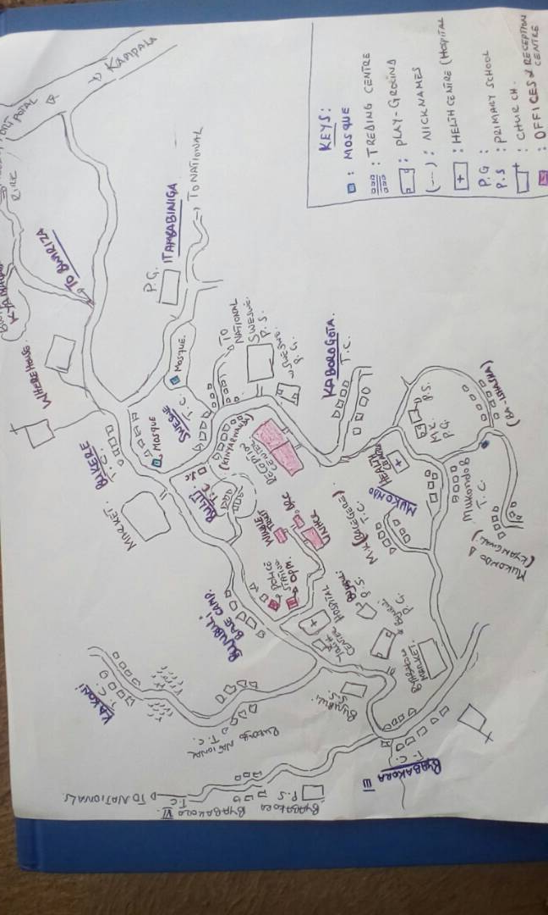

Fig xxx. A map drawn by one of the participants. The two arrows aim for the clusters Mukondo and Base Camp to illustrate their proximity but lacking access roads.

The sense of distance is pre-structured also by the access to other elements, such as means of transport with refugees mostly relying on their foot and humanitarians on their jeeps. The bigger roads are constructed by humanitarian actors in order to facilitate the infrastructure and service provision of the camp which positions the roads as centrally located and limited to this purpose. Hereby one can detect the knowledge inscribed in spaces. Whereas humanitarians rely on cars as means of transport they are limited to this spatial knowledge. Thus, when asking them for the distance to go to a certain place in the camp, their answer is based on their experience of its accessibility with a car. This can contribute to misjudgments of their own accessibility for refugees and underestimate the time people would need to reach them, since they rely on foot, but it can also overestimate distance. For example, the cluster Mukondo is one of the farthest distances with the car, since the road circles around these villages. On foot it is almost reached at the same time, linking Mukondo and Base Camp for those relying on their feet in a close proximity. Whereas a differing sense of distances might not have actual consequences for people’s everyday life in the camp, it certainly demonstrates how the same topographic environment can be experienced very differently and thus contributes to two differing ways of synthesising the camp, in regard to the cognitive mapping.

Two different ways to synthesise

Since a path pre-structures peoples mobilities and therefore their linking activities it is meaningful also in regard to synthesis and knowledge. The practice of walking links different ensembles (such as clusters and houses) together by providing a path. Moreover, while walking the people themselves become important transmitters of for example information. The continuous walking represents a mean of networking, as people are sharing news when passing by. By friendly chats information are passed on while passing houses, which was often referred to as the most crucial source of information within the camp, which was already discussed in the previous chapter on social landscaping. Yet, what can shortly be mentioned here is how an alternative set of knowledge evolves and is regularly enacted by routinized walking and spatial expertise. For instance, qua walking peoples sense of direction is informed by visible landmarkers. Thus, asking for directions might differ according who to ask and could lead to confusion for outsiders. For instance, we were directed to a house after the big tree. I was only able to find this house with the help of my translator who lived in the camp and therefore has acquired the meaning of what a big tree would be, since for me I first had to acquire what counts as a tree (is it already the very high grown bush?) let alone a big tree (what is big in this particular landscape). This gets further complicated when visible markers are linked to a symbolic meaning and detached from their actual physicality. Löw described how an institutionalized space on a place can remain intact even the constituting objects are not present anymore (Löw 2016: 168). Whereas she demonstrated this with a parking spot, which the neighbours know would belong to a particular person because her car would park there regularly, in the case of the camp places can also be synthesised according routinized activities. Once I got lost in a village and asked for directions. I was told that I had to turn right after the church. My confusion when I could not find a church was explained later, when suddenly several worshipers assembled under a big tree in the centre of the village. The practice of the church marked a location, yet only for those who had access to the respective knowledge. In a sense the person had said church, but referred to a tree, demonstrating exclusive knowledge and a particular shared meaning within the villages. Several similar incidences followed that, especially when using directions provided by village inhabitants. Hereby, in linguistic tradition (e.g. Wittgenstein) it can be once more demonstrated that words are subject of negotiated meanings and cannot be reduced to an assumed objectivity. The naming within the camp often rested on perceived characteristics and not on the technocratic designation. For examples the clusters often had alternative names and inhabitants of Kyaka II deduced the names of the clusters often by their social characteristics. For instance the cluster Mukondo D was referred to as Ishasha because the inhabitants are mostly originating from there. In the same way Kyaka II inhabitants seemed to refuse to use the externally given name of Base Camp for the centre of the offices and instead they used Bujubuli which is the Ugandan village, bordering Base camp. Whereas a different naming certainly does not challenge the authority of place making via designating the location of villages it might contribute to an identity (Agier 2002) and a sense of ownership. It again hints to processes of appropriation in which the available territory is made more convenient to the inhabitants needs (such as having a footpath) as well as the everyday interaction and exchange of information.

Fig xxx: Alternative names: Kyangwali, Ishasha, Bagegere

To summarize this section: By their regular activities, refugees exhibit a spatial expertise and incite a spatial effect, for example by creating their own paths in the camps. These paths are meaningful in several ways. First, they are creating an infrastructure actually establishing linkages rearrange accessibilities and establish their presence also physically by carving paths into the topography. Second, by their regular movement within the camp they facilitate the transfer of information but also contribute to a stock of alternative knowledge which is enabled by and enables regular interaction of Kyaka IIs inhabitants which represents a very local camp-space knowledge.

7.1.2 Conquering the Bush: Agricultural Space Making

With Kyaka II as planned settlement, people are allocated a plot of land on which they are supposed to engage in agriculture and build their own shelter on. Whereas the aspect of the actual placement, and peoples re-placing activities will be subject of the chapter eight, in this section the before mentioned primary geopractices, more particularly the agricultural practices of the inhabitants are of interest for the reproduction of the camp arrangement.
Upon a received refugee status people are allocated a plot of land within the camp. For those who have been placed on a formerly unworked plot of land, the first weeks were indeed structured by place-making in its very sense. Many of the participants who arrived years ago described how they themselves had to clear the bushes in order to start their life there and therefore employed a narrative of ‘settlers’. For example, one man noted: “It was very bushy and we were sleeping in tents under the trees. We cleared the area by ourselves.“ Through clearing, they affect the landscape, and several of my informants gestured at the area, which is nowadays prominently marked by maize fields, as we spoke, and recounted that there was only bush where you could hardly see one meter. A woman who arrived in 2000s described “It wasn’t the way it is now, at the moment you can stand over here and have a view of what is happening across the hill, previous it was different. It was all covered by the bushes”. By clearing the bushes, they actively transformed the formerly untouched gazetted government land – even stories about roaming lions were narrated –into a rural and agricultural landscape as they removed the grass and bushes and brought it under their control with agricultural means.
In addition to the need to first clear the land a man who arrived in 1993 emphasised the distance to humanitarian organisations:
“There were not many services. There was only a mobile health center they would come to the reception center and treat people from there. By then we didn’t even know that there is Bujubuli. It was only known as a place where the staff is sleeping”.
In his quote Kyaka II is represented as a fragmented territory with its elements – in this case clusters – still separated and inaccessible. Lifting this to a more abstract level this demonstrates that Kyaka II was then not yet synthesised as one coherent camp, let alone as a space prominently marked by humanitarian presence. This however, seemed to have changed and over time as the geopractices changed the landscape enormously as the following satellite images retrieved from google maps demonstrate.
Image retrieved from google earth, picturizing the area at 31.12.2010

Image retrieved 21.03.2019

The visible change of the landscape is also informed by the increase of population, with 18,720 inhabitants in 2010 (lit) to 91,365 in April 2019 (UNHCR 2019). The increase of inhabitants also intensified the demand of humanitarian infrastructure, which is also manifested in the expansion of access roads, visible on the maps. Although the transformation of a former bush to now a clearly identifiable agricultural area from space is no individual deed, nevertheless it is caused by the inhabitants geopractices collective effect, since it is them who transform the areas beside the roads into agricultural land causing the former green satellite image to turn brown and a clearly visibly demarcated living habitat. Trees were cut which takes years to grow, bushes were cut back, other plants introduced and animals were chased away. By their practices, refugees indeed carved deeply into the landscape probably effecting the landscape beyond their own presence on this place, hinting at a permanence which represents a tension discussed in more detail further on.

7.1.3 Interim Conclusion: Turning Place to Space?

Both previous examples demonstrate how it is the geopractices of the inhabitants which are rearranging the soil in a way contributing to a transformation of the landscape. What does this mean now for the general question of the reproduction of the camp?
Generally, the above examples show the activities of refugees as changing a formerly gazetted land into an area which is clearly inhabited and agricultural used. This spatial transformation is the precondition also for the cognitive process of synthesising a place with its placement into a coherent space. It also provides insights on how the process of spacing can contribute to multiple spaces existing simultaneously. To entangle the human-practice part of the camp is important, since once a space is institutionalized, it becomes a coherent element, a building block to be fitted into another space and by its fetishization itself as a human product becomes enclosed (see theoretical chapter). The above examples have therefore disclosed the human activities behind the “planned settlement” of Kyaka II and therefore made a step to de-essentializing it.
To summarize peoples practices as precondition for a coherent synthesis three points can be made. First of all, only on cleared land, shelter can be built on and people can settle and start to interact. Second these practices allow the visual identification of Kyaka II as a continuous area of land, where the zones are connected by roads, but also by little disruptions for example through green boundaries, separating the different zones. The many paths and roads are clearly connecting different elements and tie the place together. Third, since most of the inhabitants of Kyaka II employ agricultural techniques, the plots are similarly arranged, with similar crops etc., also hinting at a shared positioning of its inhabitants. More particularly this mirrors the rural development approach of the employed refugee protection approach in Kyaka II and can therefore easily linked back to the symbolic charge of refugee camps as agricultural settlements. The coherent placement and the various connections therefore spatialize Kyaka II as a coherent place and therefore provides the pre-condition to synthesis it as a space.
However, as a second aspect to conclude, these practices contribute not only to the same synthesis of space but indeed give way for alternative spaces on the same place. By their regular use and interaction, as well as selection, these geopractices demonstrate a specific spatial expertise which arises out of the everyday practices with the spatial environment as well as an individual connection to the land. By their stay, over time people collect memories, collect expertise, can trace transformations and develop senses of ownership. How this can collide with the external camp-planning will be discussed in chapter 8. Before coming to that in the following however, this situated knowledge will be displayed in the example of house construction and its further possible tensions will be discussed.

7.2 Assembling Space: Constructing a House

The following part of this chapter concentrates on practices of assembling. More particularly how people construct their own houses and how this relates to the question of the reproduction of the camp.
Housing constitutes an essential feature of everyday life, providing shelter but also a possible home. It positions people by designating them a place of temporary belonging and actual placing, and pre-determines their social relations in regard to neighbours etc. Where the house is located informs the access to waterholes, churches, schools, markets, and other meeting points, let alone the humanitarian offices and hospitals. How the house is constructed informs the possibilities to enable or hinder recreation, contribute to the feeling of safety or insecurity, or receive visitors (löw, seitenzahl). It is also linked to socio-economic status and milieu and may therefore be material expression of identity and belonging – or in Bourdieu’s words ‘habitus’ (Bourdieu 1987), and its existence and internal arrangement becomes more significant in times of personal disruption (see for example an analysis of the significance of home in times of illness and reception of care Angus et al. 2005).
Housing is therefore one material dimension in which power asymmetries are manifested and experienced. Scholars have highlighted how the material dimension of housing in situations of encampment is often characterized by the placement of people in a fixed and highly regulated arrangements where the living situation enables a high amount of control in regard to mobility as well as routines and a limited ability of privacy (Täubig 2009, Kreichauf 2015). These measures might include fences, gates but also restrictions regarding the use of common or communal goods, such as water, electricity or access and use of communal areas such as kitchens or compounds. As previously described the control exercised over and in mediation with the material dimension within the buildings contributes also to a constant “othering” as well as devaluation of the inhabitants (Hartmann 2017, Hartmann 2020). Consequently by re-placing social goods people re-take limited control over their life via the appropriation of the immediate material surrounding. A mobile tea-kitchen set, for example allows a spontaneous rearrangement of a given place into a space of belonging and thereby confronts experiences of othering also on a symbolic dimension (Hartman, seitenzahl). Others have described acts of appropriation in connection with home-making (Feldman and Stall 1994, in regard to refugee situations Brun and Fábos 2015). Especially transnational perspectives demonstrate how people uphold linkages to their previous life, for instance in carrying material goods with them, or in arranging their new house similarly and therefore create “trans-local-homes, where it is the place of origin and the place of refuge that together represent home” (Brun and Fábos 2015: referring to findings of , Eastmond 2006). Hereby often migrant practices are characterized by fragments, combining abstractions (remembering a way to cook) as well as material elements (available food) materialising in their everyday practices (Conlon 2011). According to Eastmond, home is then a place where “normal life can be lived; it is a place that can provide economic security, a social context, and a sense of belonging” (lit).

The short state of the art, demonstrates the relevance of housing. It also raises questions in regard of the house-making and the hereby linked ability of controlling ones own environment (e.g. Douglas 1991: 289). Looking at the camp-literature, the practice of constructing houses is primarily located in research revolving around urban refugees or at least camps, bordering with urban areas. Especially the dynamic of expansion was linked to questions of agency or resistance. Abourahme and Hilal explore how processes of self-urbanization, e.g. the improvement of the camps physical spaces contribute to a political space, actively confronting the always-temporality with spatial improvement leading to a permanence, calling for recognition (Abourahme and Hilal 2009). Similarly Bulle describes instances of “domestication”, e.g. gardening, the erection or movement of walls, establishment of verandas as a mean to “reconfigure[e] his or her relationship with the outside world” and ultimately as acts of resistance (Bulle 2009: 29). She argues that these operations of domestications
“open a large framework of personal or communal interactions in order to undo (deconstruct) the notion of enclosure in favor of the legitimization of residents built step by step. All these activities can perhaps be contrasted with the political representation of the camp, as a place of resistance against occupation and Israeli institutions but in fact have consequences in enlarging and changing the public domain and sphere” (Bulle 2009: 33).
Martin (2015) analyses the expansion of the refugee-houses, into the neighbouring area, producing so-called “campscapes” which seemingly blends issues of urban refugees with questions of general urban marginality (for a more general analysis see Huq and Miraftab 2020), which also hints at a social integration long before a political integration of refugees.

Drawing on these debates, yet contextualizing it to Kyaka II, the subsequent concentrates on the practice of constructing houses. In Kyaka II, a shelter is not provided but instead has to be assembled by the inhabitants. Newcomers are provided with a plot of land where they are supposed to live and farm on as well as a starting kit to construct their own shelter. In linking social goods together and actually constructing a house, people are taking control over their immediate environment. Thereby transforming the standardized kit for constructing an instant-camp-house into an individual home “for-now”, which gives shape to a certain character, flair, and socio-materiality of a camp. Whereas first of all this denotes how refugees practically assemble and arrange elements together, and by that generate a very localized stock of (expert) knowledge, it secondly also addresses their very own processes of making a home. This can be discussed as home-making following Douglas “for home starts by bringing some space under control” (Douglas 1991: 289). In the following, I thus address how inhabitants of Kyaka II are taking control over their housing situation – and home – also unveiling underlying struggles and negotiations.

7.2.1 The Humanitarian and National Architects

In Kyaka II, after the first period in the reception center, people are supposed to live in individual family shelter instead of communal accommodation. Although in Kyaka II people are supposed to construct their own houses this does not mean that they can autonomously decide how and where they build. Instead, the form of housing is pre-structured by economic constraints, humanitarian support items as well as national regulations and most of my interlocuters described how their housing contributes to a feeling of insecurity, health hazards and lacking privacy.
In order to enable newcomers to build their own houses, they are allocated a plot of land where they can build on and are equipped with plastic sheeting and – if they have additional needs with wooden poles. This is in line with the proposed shelter solutions promoted by UNHCR for planned and managed camps. Hereby UNHCR explicitly promotes that “persons of concern should build their own shelters, with appropriate technical, organisational and material support. This helps to ensure that dwellings meet their users' particular needs, generates a sense of ownership and self-reliance, and reduces costs and construction time” (UNHCR 2015). The distribution of the plastic sheeting is hereby a cost-effective measure and is supported because of its “UV-resistant; heavy duty; lightweight, flexible; large production capacities” (UNHCR 2015).
The distribution of plastic sheeting for every newcomer is also backed by national regulations, demanding that every newcomer builds his/her own house. The material the house is made of has to have a temporal character, so that it is “clear that it is only a temporary life so they can´t live too comfortable so that they would want to stay forever” as an authority figure stated. The temporary use of the land is also inscribed in the refugee regulation of 2010 which states that in the camps refugees “shall have free access to use land for the purposes of cultivation or pasturing, except that they shall have no right to sell, lease or otherwise alienate the land that has been allocated to them strictly for their individual or family utilization” (2010: part XI, 65). As the authority figure further explained the existence of permanent buildings on the land could make way for land litigations based on a complex land right in Uganda, which involves customary tenancies and is often without formal land titles. As Sebba has described for the settlement xxx this resulted in refugees acquiring land titles (Sebba 2006: 4).
The political dimension of a temporary status becomes thereby materially mediated in the regulations for refugees living in semi-permanent houses. By that the camp is “othered” and also visibly marked, first of all by the UNHCR plastic sheeting with the large emblem on it, and secondly by the semi-permanent structures in contrast to the brick houses of the neighbouring villages.

7.2.2 Refugees as Constructors

Although the national and humanitarian regulations and provisions, operate at a planning level and by that theoretically synthesise social goods into shelters, the process of constructing a house needs practical knowledge which comes only with the actual assembling as I will demonstrate in the following.
By talking to people in various stages of their house construction I could trace an ideal sequence of improving houses over time (Fig. xxx), which over time inscribe their presence more permanently and rely less on social goods provided by the humanitarians.
Different Stages of Constructed Semi-Permanent Houses
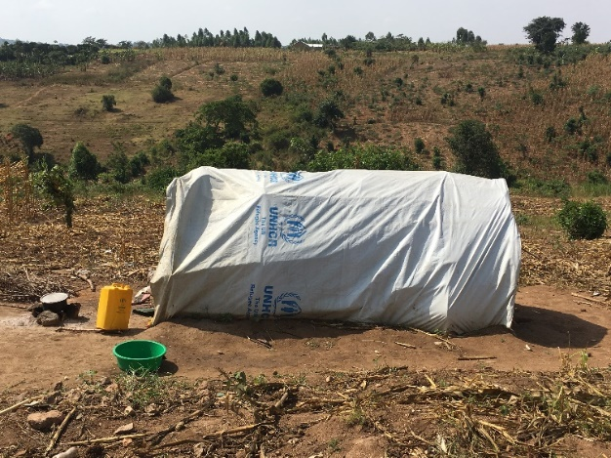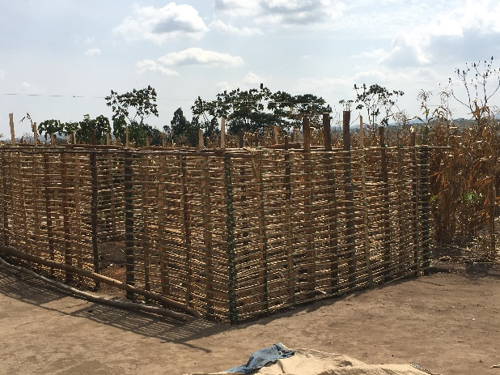
Fig xxx House with Sticks and UNHCR Plastic Sheeting Fig xxx Scaffold of a house before mud is applied 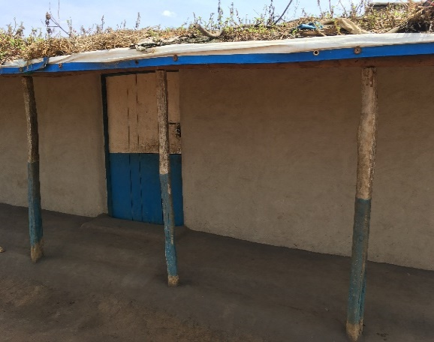 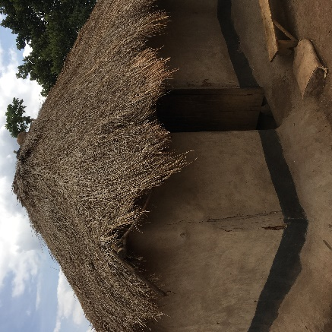
Fig xxx a finished semi-permanent House Fig XXX a grass thatched semi-permanent House
with Plastic Sheeting

What is provided by the aid organisation is only enough for the scaffold, consisting mainly out of plastic sheeting. The material has to be complemented in order to make a house and the labor has to be provided by its future inhabitants. Due to that the houses in the camp are in various stages, as the erection usually involves several steps, linking the spatial practices with a temporal component. In the beginning often the distributed plastic sheeting is used as covering a small scaffold made out of small sticks. Only when the inhabitants have resources available the house expands, by using sticks and mud to extend the building in height and use the plastic sheeting only as roof. The additional material is a mixture of planning as well as using whatever is available as one man explained the procedure:
First you measure and put ropes. Then dig a fundament and dig holes where you put the poles. Then you construct a wooden construct of poles and grass – which I planted in my garden. Then you put mud in the wooden construction. You led it dry and then put a mixture of sand, soil and water. After that you paint it with sand mixed with cowpoo and cassava leaves. The sand you collect from the valley. The soil you can take from your garden or you mix it with some better soil.
Before he was able to build a semi-permanent house (fig xxx) he had to invest some work in the garden and acquire knowledge over the quality of the soil and sand available. This quote hereby also demonstrates that people have to have a minimum knowledge on how to build it. Xxx notes that expertise is intrinsically linked with a spatial positioning, since a specific positioning entails certain role expectations, routines and repertoires. In regard to newcomers in Kyaka II this means that they have to quickly adapt their routinized knowledge on housing with the available material. Whereas for some people nothing changed, since they have built their previous houses with sticks and muds, for others their materials were not available (such as grass for the roof). Others have lived in previously built houses and had no previous knowledge whatsoever and by that relied on the help of others. Quickly linking this back to the idea of space being constantly reproduced by routines, the construction of a house can cause deviation from peoples spatial routines. Finding themselves in a different living situation than before demands other routines, as well as skills and knowledges. How people can adapt and cope with the new spatial situation, rests on their ability “to learn new things and on the accessibility of rules and resources“ (Löw 2016: 155).

It has been discussed in the previous chapter (social landscaping) how the adaptation to the life in the camp, is facilitated by other inhabitants who often share their knowledge with newcomers. In regard to construction, one of these information channels is mediated by the mutual dependency of the inhabitants of Kyaka II. Especially those who lived in brick houses before relied on others to share their expertise, or at least as a role model they can copy from. This dependency plays out in joint operations, for example, for the erection of taller structures manpower is needed to erect the poles as well as attach the mud. I witnessed one of these events where approximately 30 persons were present, who had a clear division of labour and made chains to pass on the mud. As one participant explained this was the usual procedure in his village, and it was almost obligatory to participate in it. By that techniques of construction seem to spread within the camp. Hereby specific spatial knowledge becomes obvious and how it can be gained in the process of actually using things.

Indeed this practical knowledge can exceed or at least challenge the planning authority of the humanitarians. One OPM officer described the failure of contracting an outsider to build houses for PSNs in the camps. By accounts of the officer, he was adapting the technique of the people in the camp and used mud. However, he did not start early enough as this had to be done in the dry season, so that the mud wouldn’t be washed away by the rain. Ultimately, he failed and the organization had to start anew after the rain. This officer acknowledged the expertise of the refugees and admitted:
For them they told us if they have told us early, we would have advise you due to the seasons to start early because the construction and the making the bricks takes time. By the time rain comes we already would have had roof and your house is not wet.
Specific knowledge can therefore only be acquired in the actual engagement with the material, marking a separation between the resources of the humanitarians and the lack of actual expertise which rather lies with their actual users. This also expands to distributed humanitarian items, for instance when refugee could precisely state the lifespan of a plastic sheeting, depending on the usage, which was much shorter than the lifespan calculated in the support schemes.
The reliance on practical knowledge negotiates national and humanitarian regulations, since it relies on practical experience rather than formalized rules. Indeed, what many interlocuters described is that in the context of limited resources as well as legal restrictions the process of constructing a house seems to be characterized by constant improvisation and incremental progress which resonates with the process of learning to cope with new spatial environments and demands and a constant negotiation between old routines and available rules and resources in the new context (Löw 2016: 155). What I observed was an incremental construction which takes place whenever resources are available. Often there is a combination of what is available to as well as what is preferable by the inhabitants in Kyaka II. For example a man explained me that when he still received full ration he could save some money which eventually enabled him to buy one iron sheet after the other until his whole roof was covered by it. Then he could remove it and sell the plastic sheeting of UNHCR. The same applies to people who told me that they have sold of the distributed poles because they could not afford to construct a house, hold by poles but instead traded it on the market agains plastic sheetings to cover their small structure in the meantime.
Broadening the view and considering the humanitarian structures inherently present in the camp, such housing practices then furthermore reveal negotiations of local regulations. Within the incremental process of house construction, legal regulations are sometimes opposed. Some participants described for example a form of trial and error when constructing their house, sometimes contradicting the national regulations with placing new elements on the roof:
It depends on the chance. The month I build the house, it is the month they said we are allowed to build a house with iron roofing. I build my house and no one stopped me and up till now. No one has ever said anything to me.
This hints at a certain room to manoeuvre people have in regard of their housing practices but also at a certain degree of arbitrariness and luck, since others have described how their iron roof was removed by OPM by the time this was still illegal. Moreover it demonstrates how change is most likely when peoples routines are disrupted and they have to quickly adapt to the new context (Löw 2016: 155). Yet, before it can cause change in the institutionalized arrangement it has to take place “collectively with appeal to relevant rules and resources” (Löw 2016: 156).
To a small extent this seemed to have happened in Kyaka II. An authority figure justified the recent legalizing of iron roofs by discharging its permanent character as it can be taken off easily, even when the house has to be taken down. Also humanitarian provisions can counteract these informal preferences. For example, UNHCR has recently promised to bring electricity to a village in the camp. Yet, rumours spread that they can only connect houses with iron sheeting as other roofs are not safe to put electricity there because of the easily burnable material. This provides a strong incentive for people to make their house with iron sheets. These sometimes contradicting rules and practices are contributing to an environment of trial and error, whereby the persistence of practices are representing a powerful tool.
In sum, when entering Kyaka II people have to gain certain expertise on the construction of houses, since there is no housing provided. Although the primary goods are distributed by the humanitarians it is the other inhabitants who are providing certain anchor points, by providing advice or at least a model other people can copy from. The various stages of housing are informed by people´s individual trajectories as well as available resources. By that humanitarian goods and national regulations can experience adaptations in case of mismatch between an actual need and restrictions.

7.2.3 Refugees as Painters

When observing the different types of houses in Kyaka II what can be stated is that, although the elements are pre-structured by the national regulations and the humanitarian distributed material this does not mean, that houses are similarly assembled. On the contrary even with the limited resouces houses do provide means of distinction, either through cleanliness, decoration or technique. These means of distinction can also be framed as space appropriation as people adapt it to their specific needs and exercise control over their immediate environment.
It also stretches the prestructured way of a refugee house, by including other elements (curtains, iron sheets etc.) than provided. Even the actual structure of some houses did remarkably exceed to what the shelter kit of UNHCR would enable to, for example pointing to the second floor in fig. xxx. Thus, through the engagement with material elements they become transformed in something meaningful – e.g. demonstrating skills or taste or wealth and certainly contribute to individualization.
Although everyone starts with the same humanitarian kit, of course people are differently positioned regarding various forms of capitals, such as skills, economic capital but also networks etc. Thus, also individual skills and taste enters this arrangement. For instance, in one village asking inhabitants about their building techniques, everyone referred to “the carpenter”, the man who managed to build a two-storey house just as he had back home. Similar to this people directed my attention to their decorations, such as curtains made out of different materials, or a particularly neat veranda.
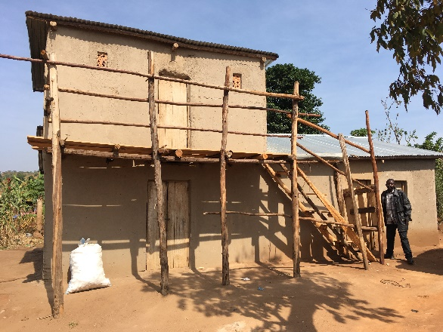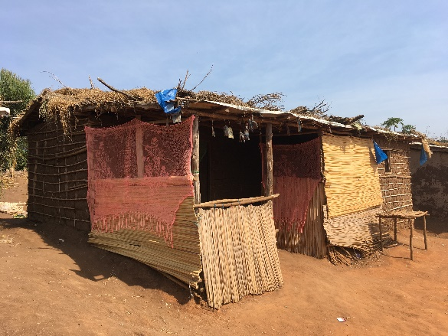
Fig xxx

Whereas every house is the result of an individual positioning, there are nevertheless collective effects. For instance during a transect walk, where we discussed architecture and building techniques with participants, they drew my attention to the different village-styles. Whereas in one zone (Buliti) the majority of houses was grass-thatched in another zone (xxx) the houses were particularly neat. The participants linked certain styles with different ethnic backgrounds and thereby deduced from spatial arrangements to an assumed identity. The material arrangement therefore synthesise with elements outside the camp and links people to an assumed collective outside the camp, momentarily rejecting the heuristic marker of being a refugee. Very bluntly speaking then the murials on the wall are dominating the arrangement and synthesis and by that reducing the symbolic effect of the humanitarian emblem on the plastic sheeting. Moreover by transforming the camp to a landscape of informal insider information the appropriation of space is further proliferated.
However, participants also agreed that the specific socio-economic fabric in the village plays a role, as well as the sharing of expertise. Based on that it seems that the collective clustering of techniques is partly based on shared backgrounds, the same structural limitations but also spill-over effects in neighbourhoods. The spill-over effect of aestethics can be described in regard to the paintings on the houses (Fig xxx). Although traditionally a technique from the ethnic group of Bagegere the participants of the transect walk agreed that this technique spread within the camp producing a diversity of coloured houses and even beyond the camp to houses of nationals. When I asked a woman why she painted her house she said that she liked the decoration, whereas a man said that these were his children’s paintings, referring to something they have learned in school, whereas other children seemed to process their experiences in war (fig xxx).
Impressions of the techniques of Colouring Houses

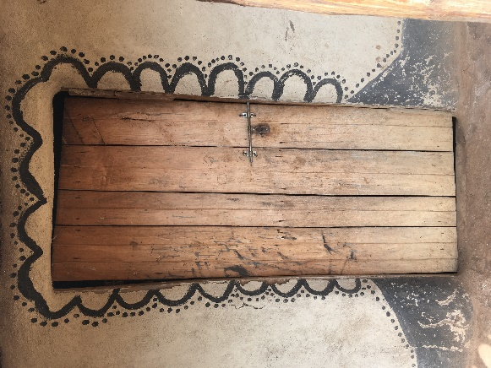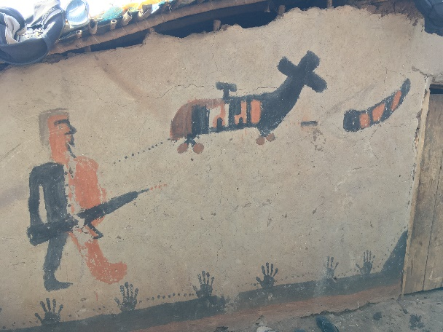
Fig xxx traditional painted house Fig xxx painting of a child

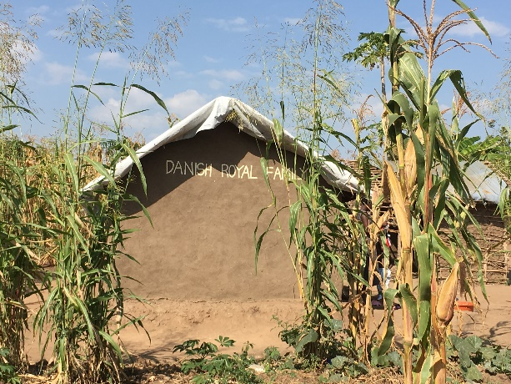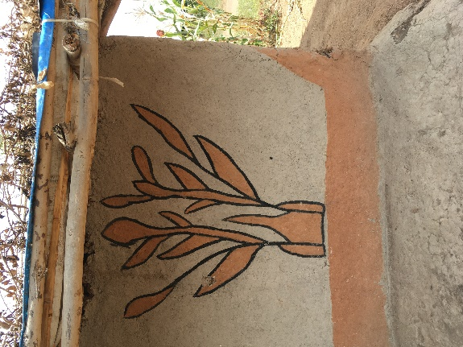
Fig xxx, “Danish Royal Family” Fig xxx coloured house for
is inscripted on the House the intention of decoration

What is more in those murials they can be identified as spatial appropriation in order to change the house into a learning-space (Elorduy 2020) but also as spatial-visual appropriation. By painting houses visibly for everyone these aesthetic techniques can also become a public comment, critique or negotiation of being a refugee in the camp. They can publicly cope with traumatic experiences (fig xxx), many of the inhabitants share, they can ironically comment on the material deprivation and contrasting it to the life (of royals) in the west (fig xxx), and also reproduce boundaries or symbols of belonging by using traditional paintings (fig xxx), remembering the techniques at place in their regions of origin. Overall, how houses are assembled and later on decorated are various and diverse practices which rest on very individual motivations and objectives. As a result of these individual practices, however collectively they re-arrange the camp by appropriating what is needed, liked and available for housing solutions in the camp.

7.2.4 Collision of Planning and Practice: Between Temporary Housing and Permanent Living

Theorizing the findings above one can start by reminding that building a house in its very sense is grasped by the term spacing, referring to acts of “erecting, deploying, or positioning” (Löw 2016: 134). Spacing is pre-structured, in the case of the construction of housing, by national and humanitarian rules and regulation, on the way houses have to be built and which social goods are distributed. The actual spacing however is done by the inhabitants, since it is their task to assemble the goods and arrange them in order to build a house. The separation between planning and execution level hints at the existence of the constitution of two spaces, since every placement is “preceded by an operation of synthesis” (Löw 2016: 136). A camp-house is therefore first of all synthesised in planning bureaus of humanitarian actors and offices of the prime minister and then assembled by the inhabitants, which also synthesise their houses in a particular way which is, apart from peoples own common sense, also based on practical considerations, evaluating the actual context.

Since the process of house construction takes place in an environment, mostly characterized by its lack of available resources for most of my interlocuters, peoples practices are informed by improvisation and incremental progress. With no linearity, often houses are in itself fragmented, for example with half a roof of iron sheeting and half plastic. Others again reported they had to sell their plastic sheeting, since more pressing needs were to be filled. With the growing differentiation of housing, departing from the distributed humanitarian set, the “reading” of material markers becomes more difficult for outsiders, first by the vanishing humanitarian symbols blurring the boundaries to the neighbouring nationals, but also by establishing different styles, specific skills and a local transfer and translation of both contributing to a growing visual diversification also between the zones.
Indeed, presuming these various stages of houses as a tempo-spatial expression of people’s abilities in the camp, there is a certain linearity to be detected, which is characterized by a growing distance to what was planned as shelter by the humanitarians. Mostly in the first stages of housing, the UNHCR plastic sheeting is a predominant visual marker but in the following stages the plastic sheeting vanishes out of sight. It becomes covered with grass and woods, in order to make it more durable and fix leaking spots and ultimately – if people have the resources – it becomes replaced with a more durable solution. Additional plastic sheeting then gets sold and find its ways into the neighbouring Ugandan village, transgressing the visible boundary between camp and Ugandan land with travelling objects. Whereas the vanishment of humanitarian emblems with further progress of the housing is primarily symbolically, due to the entanglement of symbolic and material dimension of arrangement this can become meaningful. As discussed in the theoretical chapter, arrangements which are poor of material markers are often linked together by a strong symbolic component. The vanishment of humanitarian emblems at sight reduces the goods, charged with symbolic meanings which in effect merges the camp with the neighbouring land.
Thus, in the subject of housing one can detect two tendencies which seem to be contradicting at first sight. In the constant improvisation within the process of constructing their houses, the visual difference to the nationals becomes less, yet the internal differentiation increases. What seems to be contradictory at first sight starts to make sense when reminding that the effect of the refugee protection regime is the homogenization of the targeted populations, since they are all equipped with the same utensils and framed under the same approach. Whereas it is the humanitarian effect which situates them as farmers on a plot of land, under a UNHCR plastic sheeting, over time their own biographies embodied in skills, knowledges, tastes etc. becomes merged with the collectivizing restrictions, with everyone coping slightly differently to it. By the means of their housing, the visible landscapes thus becomes less an image of ‘refugeeness’, but more an image of diverse social practices.

7.3 Conclusion

This chapter was concerned with peoples practices in regard to matter. More specifically, first the geopractices of the inhabitants were analysed, referring to the use and rearrangement of soil, and second the assembling and placement of elements on the plot of land people are given was demonstrated with the example of house construction. What is now the common finding of these different examples?
First of all this chapter demonstrated how Kyaka II as a coherent place already by its very substance relies on the spacing of the inhabitants. The national and humanitarian rules and regulations hereby pre-structure their practices by providing them with a place to live on, as well as provided goods, by restricting peoples spacing with rules and regulations on for example how they are allowed to build, what they are allowed to plant etc. but also more indirectly by their social and economic positioning as refugee in Kyaka II which leaves them little choice than to engage in agriculture (more particularly discussed in chapter xxx). Hereby their practices, although classified as agency in the sense having an effect (Giddens 1984)(seitenzahl) are not overcoming the humanitarian order, but instead constantly confirm the approach applied in Kyaka II, by facilitating the infrastructure but also the synthesis of the camp.
However, all of these practices share a side-effect which produces constant tension with the paradigm of temporality a refugee camp is supposed to serve and therefore at least disrupt the coherence of this approach. By their geopractices, refugees indeed carved deeply into the landscape probably affecting the landscape beyond their own presence on this place. Trees were cut which takes years to grow, bushes were cut back, other plants introduced and animals were chased away. By their practices they therefore have created a permanent physical marker. This mirrors the tension of refugee camps in general which are at least imagined as temporal, designed as a transitional situation for the short-term accommodation and support of refugees. Yet, camps like Kyaka II represent a protracted refugee situation in which many of the inhabitants are staying for decades The actual permanency poses pressure as it collides with the political idea of not naturalizing refugees as permanent citizens (Cole 2017). As such camps are supposed to remain as “permanent provisionality” (Inhetveen 2010: 253 own translation). This tension also plays also out as material negotiation and becomes practical in regard of housing since refugees often live for decades in Kyaka II for what temporary houses are not sustainable.
In the course of building a house and more particularly by the process of diversification and improvement, the housing become more stable and concrete with people using more permanent materials over time. This however stands in contrast to the temporary political status which is supposed to be spatialized by the only availability of temporary materials. Whereas in Kyaka II, this negotiation is predetermined by the prohibition of permanent structures for refugees and their incremental opposition, Abourahme (2015) carved out how the material element of cement “‘concretizes’ presence of a Palestinian refugee camp“ and “exacerbate[es] tensions between rootedness and return” (Abourahme 2015: 214). By that he introduces the idea of cement as mediator linking people and element in a dynamic composition by what it is assigned with multiple meanings. This addresses the dynamic of constructing houses as agentic process, in the sense of assembling and bringing people and things into (new) mutual constitutive relationships. Consequently refugeehood is “not only […] a fixed ontological marker, but […] an association, a contingent collective made and remade in the assembling” (Abourahme 2015: 212).
While in the case of the Palestinian refugee camp cement itself became the mediator negotiating between temporariness and permanence, in Kyaka II cement and any other permanent structures are prohibited by camp regulations. However, this section explored how refugees’ engagement with material elements of housing reproduce, challenge and negotiate their temporary position in the camp. In effect, people are practically challenging the material composition of a refugee, due to a lack of concrete not by “concretizing” (Abourahme) their presence but nevertheless by materializing their permanent stay when rearranging the elements on their plots and in their housings. As an effect, inhabitants of Kyaka II are challenging their temporary status in a very practical way in their everyday practices.
Whereas this seems to be a primarily abstract point to make, this also entails at least a psycho-social dimension as well. Whereas the actual control of these spatial practices seems to be challenging the temporality is in multiple aspects pre-structured, and interlocuters have linked their inability to plant permanent crops to their general inability to plan, due to fears of repatriations, hopes of resettlement or returns to their inability. This condition was linked to a specific condition of being a refugee: Not being able to control ones own time beyond the immediate situation. Planning is a crucial ability in order to achieve ontological security (Giddens 1984: 6). In this regard, the planting of permanent crops as well as constructing of permanent houses can also hint at an act of regaining control.

References
(2010) The Refugees Regulation. OPM. Uganda.
ABOURAHME, N. (2015) 'Assembling and Spilling‐Over: Towards an ‘Ethnography of Cement'in a Palestinian Refugee Camp'. International Journal of Urban and Regional Research, 39(2): 200-217.
ABOURAHME, N. and HILAL, S. (2009) 'Intervention:(self) urbanization and the contours of political space in Dheisheh refugee camp'. Jerusalem Quarterly, (38).
AGIER, M. (2002) 'Between War and City: Towards an Urban Anthropology of Refugee Camps'. Ethnography, 3(3): 317-341.
ANGUS, J., KONTOS, P., DYCK, I., MCKEEVER, P. and POLAND, B. (2005) 'The personal significance of home: habitus and the experience of receiving long‐term home care'. Sociology of Health & Illness, 27(2): 161-187.
APPADURAI, A. (1988) The social life of things: Commodities in cultural perspective, Cambridge University Press.
BEAUDOU, A., CAMBRÉZY, L. and ZAISS, R. (2003) Geographical Information System, Environment and Camp Planning in Refugee Hosting Areas. Approach, methods and application in Uganda. Bondy, Institut de recherche pour le développement (IRD).
BENNETT, T. and JOYCE, P. (2013) Material powers: Cultural studies, history and the material turn, Routledge.
BOURDIEU, P. (1987) Die feinen unterschiede, Suhrkamp.
BRUN, C. and FÁBOS, A. (2015) 'Making homes in limbo? A conceptual framework'. Refuge: Canada's Journal on Refugees, 31(1).
BULLE, S. (2009) '" We Only Want to Live": From Israeli Domination Towards Palestinian Decency in Shu'fat and Other Confined Jerusalem Neighborhoods'. Jerusalem Quarterly, (38).
CASTLES, S. (2003) 'Towards a Sociology of Forced Migration and Social Transformation'. Sociology, 37(1): 13-34.
CERTEAU, M. D. (1988) The practice of everyday life, Berkeley, Calif. u.a., Univ. of California Press.
COLE, G. (2017) 'Beyond Labelling: Rethinking the Role and Value of the Refugee ‘Label’ through Semiotics'. Journal of Refugee Studies, 31(1): 1-21.
CONLON, D. (2011) 'A fractured mosaic: encounters with the everyday amongst refugee and asylum seeker women'. Population, Space and Place, 17(6): 714-726.
DOUGLAS, M. (1991) 'The idea of a home: A kind of space'. Social Research: 287-307.
DOUGLAS, M. (2003 [1966]) Purity and danger: An analysis of concepts of pollution and taboo, Routledge.
EASTMOND, M. (2006) 'Transnational returns and reconstruction in post‐war Bosnia and Herzegovina'. International Migration, 44(3): 141-166.
ELORDUY, N. A. (2020) 'The long-term camps in the East African Rift'. In FIDDIAN-QASMIYEH, E. (ed.) Refuge in a Moving World: Tracing refugee and migrant journeys across disciplines. London, UCL Press, pp. 362-381.
FELDMAN, R. M. and STALL, S. (1994) 'The politics of space appropriation'. Women and the Environment. Springer, pp. 167-199.
GIDDENS, A. (1984) The constitution of society: Outline of the theory of structuration, Univ of California Press.
GÜNZEL, S. H. (2010) Raum : ein interdisziplinäres Handbuch, Stuttgart ; Weimar, Metzler.
HARTMANN, M. (2017) 'Spatializing Inequalities. The Situation of Women in Refugee Centres in Germany'. In KRAUSE, S. B.-Z. U. U. (ed.) Gender, Violence, Refugees. Berghahn Books, pp. 102-126.
HARTMANN, M. (2020) 'Analyse: Sammelunterkünfte für Geflüchtete zwischen An-und Ent-Ordnung'. Zwischen An-und Ent-Ordnung. Springer, pp. 191-345.
HICKS, D. (2010) 'The material-cultural turn'. The Oxford handbook of material culture studies: 25-98.
HOLZER, E. (2014) Humanitarian crisis as everyday life. Sociological Forum. Wiley Online Library, pp. 851-872.
HUQ, E. and MIRAFTAB, F. (2020) '“We are All Refugees”: Camps and Informal Settlements as Converging Spaces of Global Displacements'. Planning Theory & Practice, 21(3): 351-370.
HYNDMAN, J. (2000) Managing Displacement. Refugees and the Politics of Humanitarianism, Minneapolis/ London, University of Minnesota Press.
INHETVEEN, K. (2010) Die Politische Ordnung des Flüchtlingslagers. Akteure - Macht - Organisation. Eine Ethnographie im Südlichen Afrika, Bielefeld, transcript Verlag.
KREICHAUF, R. (2015) 'Das Flüchtlingslager–Raumtheoretische Zugänge'. Ebner von Eschenbach, Malte et al.(Hg.): Sozialräumliche Forschungsperspektiven verschiedener disziplinärer Zugänge. Leverkusen.
LATOUR, B. (2005) Reassembling the social: An introduction to actor-network-theory, Oxford university press.
LÖW, M. (2016) The Sociology of Space: Materiality, Social Structures, and Action, Springer.
MAC GINTY, R. (2017) 'A material turn in International Relations: the 4x4, intervention and resistance'. Review of International Studies, 43(5): 855-874.
MALKKI, L. (1992) 'National geographic: The rooting of peoples and the territorialization of national identity among scholars and refugees'. Cultural Anthropology, 7(1): 24-44.
MARTIN, D. (2015) 'From spaces of exception to ‘campscapes’: Palestinian refugee camps and informal settlements in Beirut'. Political Geography, 44: 9-18.
MOULD, O. (2018) 'The not-so-concrete Jungle: material precarity in the Calais refugee camp'. cultural geographies, 25(3): 393-409.
NEWHOUSE, L. S. (2015) 'More than mere survival: violence, humanitarian governance, and practical material politics in a Kenyan refugee camp'. Environment and Planning A, 47(11): 2292-2307.
POISSON, C. W. A. E. (2013) 'Using GIS as a planning and coordination tool in refugee camps in South Sudan'. Humanitarian Exchange. Special feature: Gender-based violence in emergencies, 57: 20-23.
QUINN, J. A., NYHAN, M. M., NAVARRO, C., COLUCCIA, D., BROMLEY, L. and LUENGO-OROZ, M. (2018) 'Humanitarian applications of machine learning with remote-sensing data: review and case study in refugee settlement mapping'. Philosophical Transactions of the Royal Society A: Mathematical, Physical and Engineering Sciences, 376(2128): 20170363.
RAMADAN, A. (2013) 'Spatialising the refugee camp'. Transactions of the Institute of British Geographers, 38(1): 65-77.
RASHID, K. J., HOQUE, M. A., ESHA, T. A., RAHMAN, M. A. and PAUL, A. (2021) 'Spatiotemporal changes of vegetation and land surface temperature in the refugee camps and its surrounding areas of Bangladesh after the Rohingya influx from Myanmar'. Environment, Development and Sustainability, 23(3): 3562-3577.
SCHROER, M. (2006) 'Räume, Orte, Grenzen. Auf dem Weg zu einer Soziologie des Raums. Orig'. Ausg. Frankfurt aM: Suhrkamp (Suhrkamp Taschenbuch Wissenschaft, 1761).
SCHROER, M. (2019) Räume der Gesellschaft, Springer.
SEBBA, K. R. (2006) Land conflicts and their impact on refugee women's livelihoods in southwestern Uganda. New Issues in Refugee Research. Geneva, UNHCR.
SERRES, M. (2013) Erfindet euch neu!: eine Liebeserklärung an die vernetzte Generation, Suhrkamp Verlag.
SMIRL, L. (2015) Spaces of aid: How cars, compounds and hotels shape humanitarianism, Zed Books Ltd.
TÄUBIG, V. (2009) Totale Institution Asyl: empirische Befunde zu alltäglichen Lebensführungen in der organisierten Desintegration, Beltz Juventa.
THOMAS, J. (2000) Ethnocide: A cultural narrative of refugee Detention in Hong Kong, Ashgate Aldershot.
TOMASZEWSKI, B., AL-NAJDAWI, N., MARTIN, J.-L., TEDMORI, S., OMONDI, I. and HAMAD, Y. (2017) Using Geographic Information Systems (GIS) in Za'atari refugee camp, Jordan for refugee community information management and mobilization: The RefuGIS project. 2017 IEEE Global Humanitarian Technology Conference (GHTC). IEEE, pp. 1-10.
UGANDA (2006) The Refugees Act 2006. Kampala, Government of Uganda.
UNHCR (2015) Handbook for Emergencies.
UNHCR (2019) Uganda - Refugee Statistics April 2019 - Kyaka II. In OPM/UNHCR (ed.).

Things = fixed composition, Latour
Mapfugees https://mapfugees.wordpress.com/why-map-refugee-camps/
https://mapfugees.wordpress.com/why-map-refugee-camps/
See for example the Humanitarian OpenStreetMap Team, which provided a rich data set on refugee situations in Uganda with the participation of refugees. Dataset available under https://data.humdata.org/search?q=hotosm+uganda, the projects online presence: https://www.hotosm.org/projects/bridging-data-gaps-mapping-refugee-contexts-in-east-africa/
A casual remark while we shared a lift to the nearest town.
Interview with elderly female Congolese, 22.11.2016, Mukondo, Burundian Male, Healer, 07.12.2016, Sweswe, Congolese Female, 15.06.2017, Kaberogota
The same applies to Kyangali etc.
Discussion with three Congolese elderly women, 16.06.2017, Itambaniga
Congolese Female, extension worker, 07.12.2016, Base Camp
Interview with male congolese, 18.06.2017, Sweswe
Interview with Community Service from OPM, 18.11.2016
Conversation with a Congolese male, during the transect walk on the 8th of July 2017
A Group of New Arrivals from DRC, 06.12.2016, Reception Centre
Interview with Community Service from OPM, 18.11.2016
Pastor from DRC, 15.06.2017, Sweswe . Also others have described to sell plastic sheeting e.g. Burundian Male, Healer, 07.12.2016, Sweswe; Two women from DRC, 08.12.2016, Byabakore
A Group of New Arrivals from DRC, 06.12.2016, Reception Centre
Pastor from DRC, 15.06.2017, Sweswe
Camp Commandant, 10.07.2017, Base Camp
Member of a Cultural Group, FGD, 16.11.2016, Bukere
Interlocuters on the transect walk, 08.07.2017
Burundian Male, Healer, 07.12.2016, Sweswe
Interaction on a transect walk, 07.07.2017, Mukondo
Interaction on a transect walk, 07.07.2017, Mukondo

